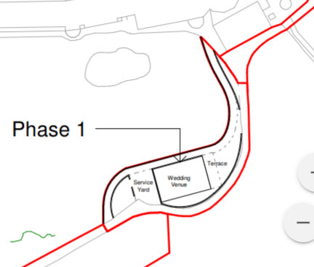

18th Green on Nicklaus Golf Course

18th fairway on Kernow Golf Course

18th Green on Kernow Golf Course

9th Green on Kernow Golf Course

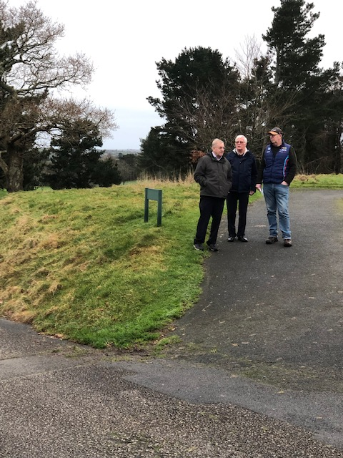  
  
Wedding venue siting behind three people  
  
  
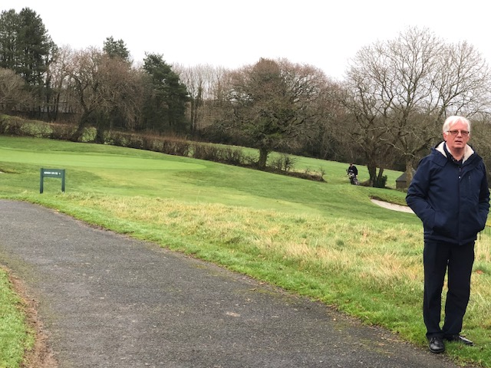  
  
Closeness to 18th Green on the Kernow Couse in the background  
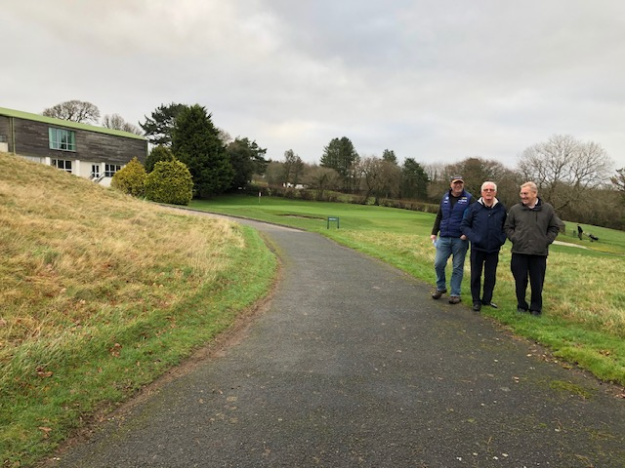  
  
  
  
Access single path to wedding venue with 18th Green of the Kernow Golf Course in the background  
  
  
  
  
  
  
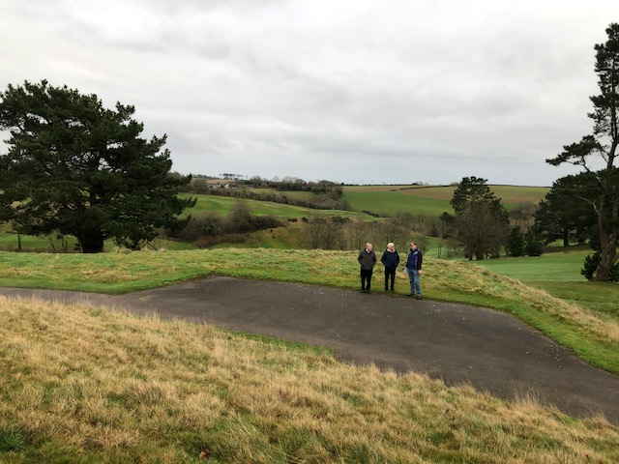  
  
Three people demonstrate site of wedding venue with fairway of the 18th hole of the Kernow Course in the background  
  
  
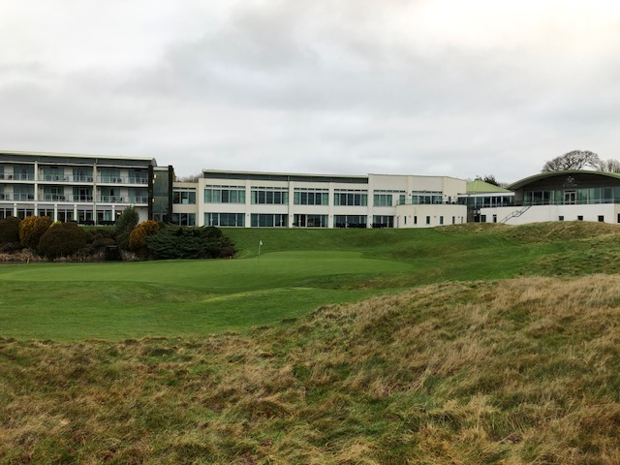  
  
Turned around to demonstrate how close the Wedding Venue is the18th Hole on the Nicklaus Course  
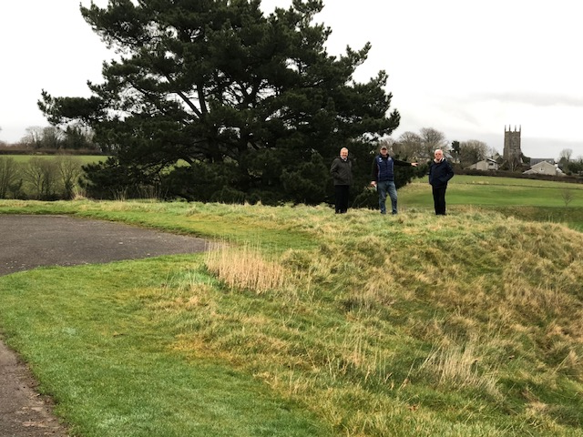  
  
Another view of where the wedding venue is with St Mellion Village Church in the background  
  
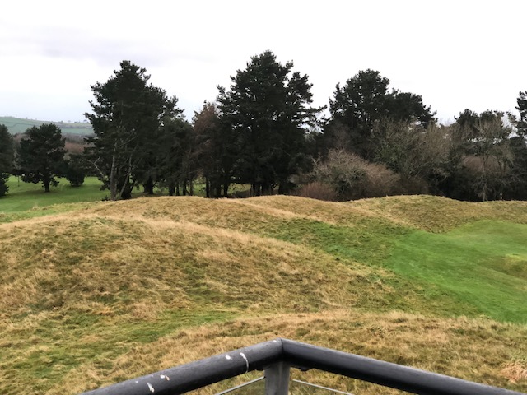  
  
View of wedding venue site from the Balcony at hotel complex. The grass humps are behind the 18th Green of the Nicklaus course  
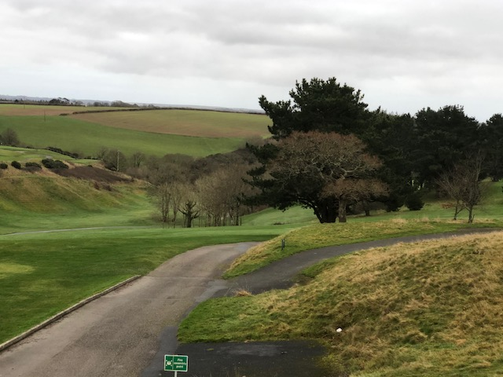  
  
Another view of single track access to the wedding venue with the 18th fairway of the Kernow course in the background  
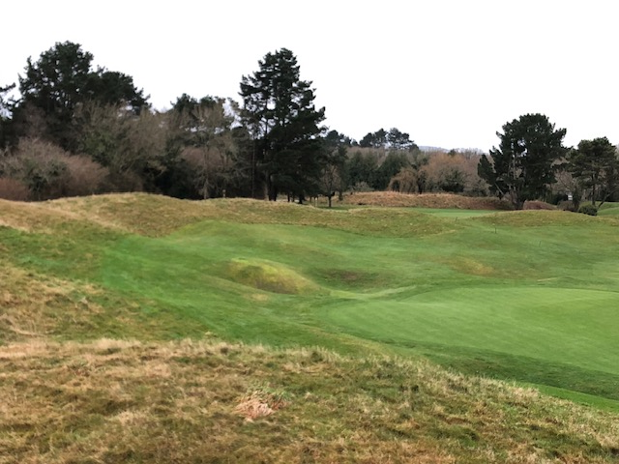  
  
Another view to show closeness of wedding venue to 18th Green of the Nicklaus course in forefront and 9th Green of the Kernow course in the background

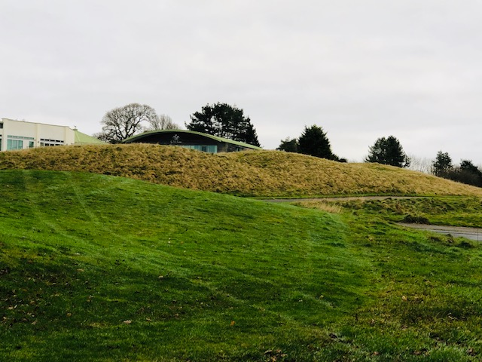  
  
Back of 9th Green of the Kernow Course with the service yard being between the two paths on the right. St Mellion Oval Roof in background where I took balcony shot from  
  
  
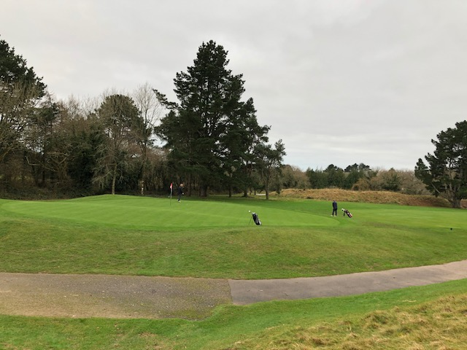  
  
Path behind 9th Green on Kernow Course so show closeness  
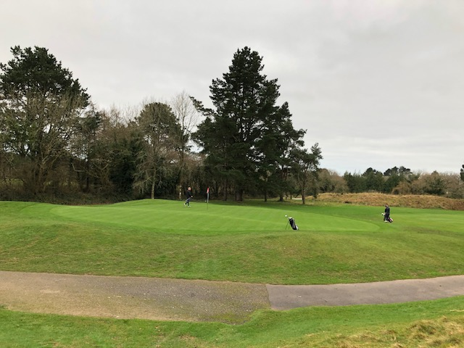  
  
Again the 9th Green but if you look at the grassy mounds in the back ground on the right, that is where they want to build 4 holiday homes in Phase 2  
  
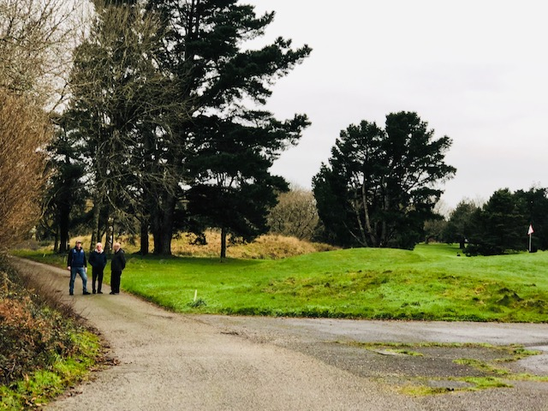  
  
The three people are standing on the access single track road to the 4 holiday homes on the grassy mound in the background with the 9th Green on the Kernow Course to the right