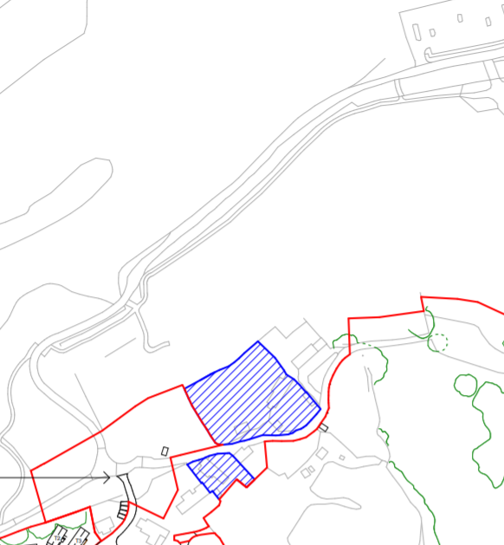

Single road access to Timeshare Village

8th Green on Kernow Course

Current golf and leisure

centre car park

18th Fairway on Nicklaus Course

Entrance to Timeshare Village

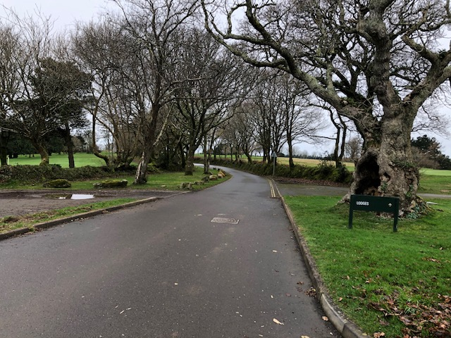  
  
Single road access to timeshare village between the 18th fairway of the Nicklaus course on the left and the 8th hole of the Kernow course on the right  
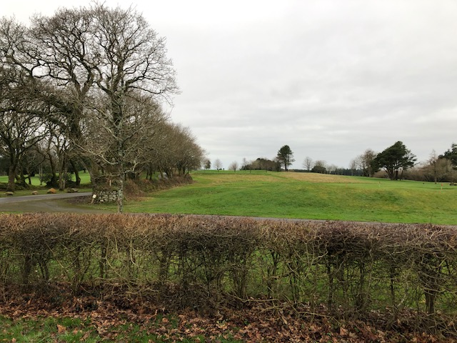  
  
Looking up from the car park to the 8th green of the Kernow Course  
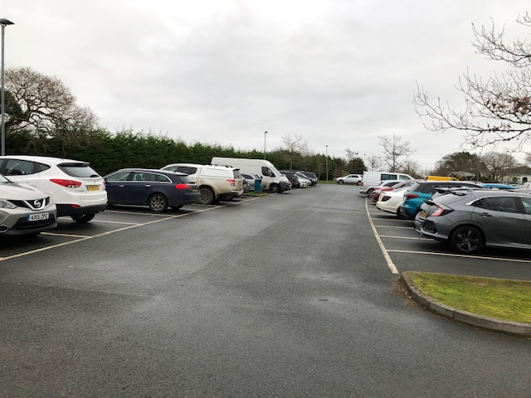  
  
Car park for golf & leisure centre virtually full on Sunday 5th January 2020 in low season  
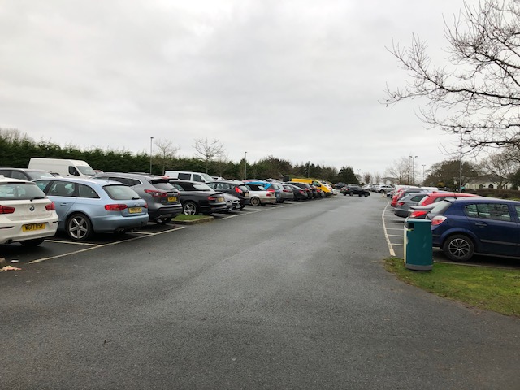  
  
More evidence that we do not have sufficient parking at the moment without the introduction of 230 holiday homes

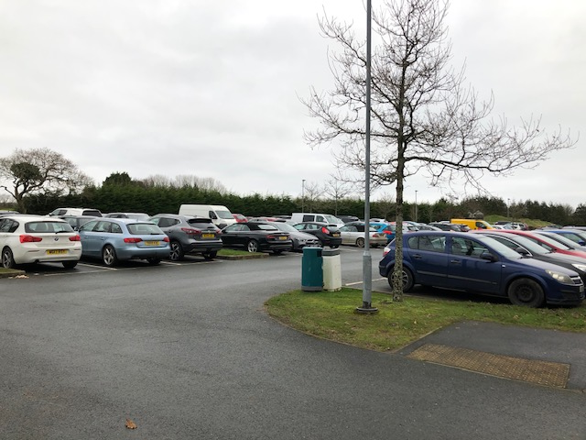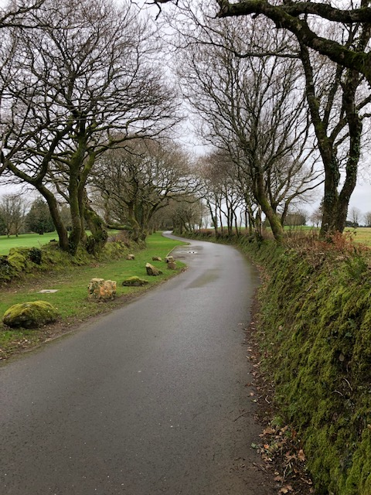  
  
The access road cannot cope with the volume of traffic proposed and will also destroy playing the two golf courses with the noise distribution  
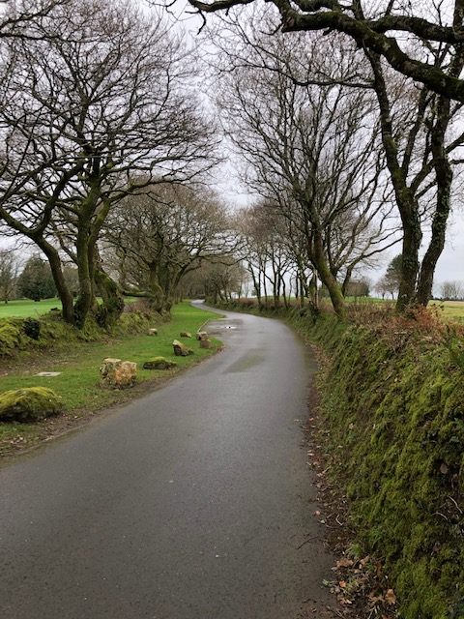  
  
The grassy walls are the boundaries of each golf course  
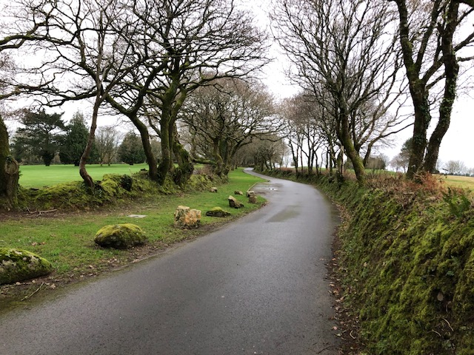  
  
Stray golf balls regularly hit the road which with increased congestion will endanger car owners  
  
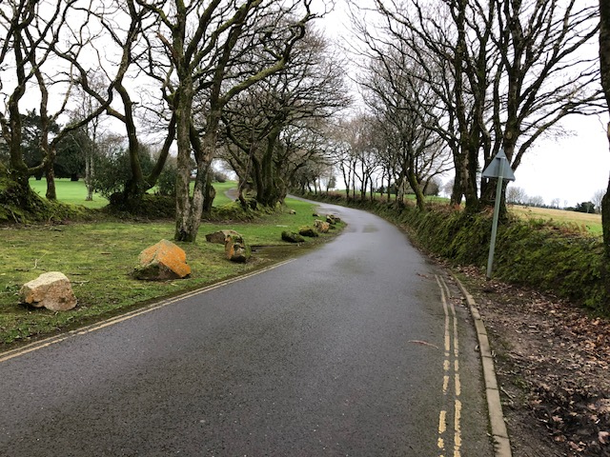  
  
The boulders are there to stop people parking due to the current over congestion of the car park