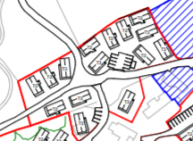

Phase 2 plan

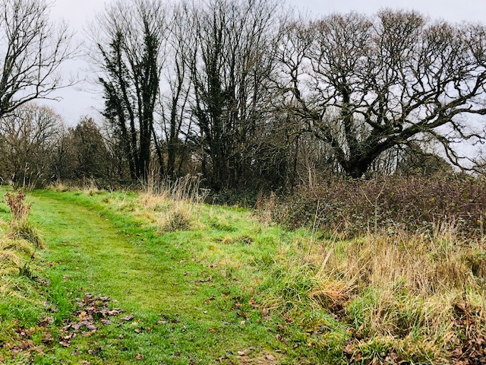

Path from entrance to Timeshare Village to 9th hole on the Kernow golf course where they are going to build 9 holiday homes

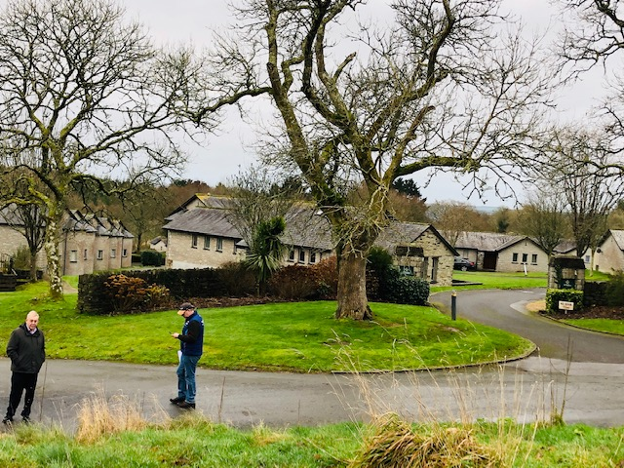

Turning around entrance to Timeshare village

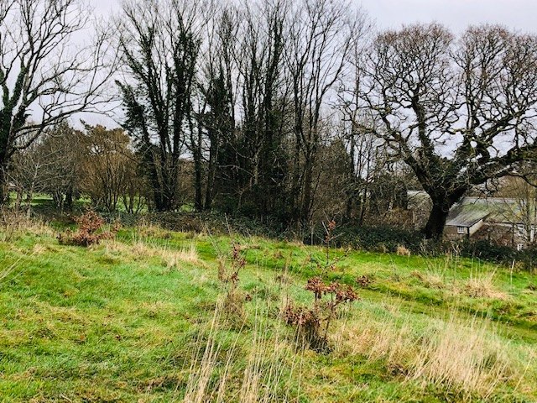

Another view of path to 9th hole of the Kernow and closeness to private property on right hand side

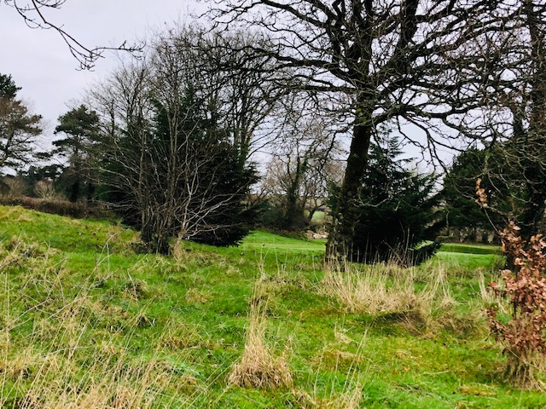

Another view where 9 holiday homes are being built  
  
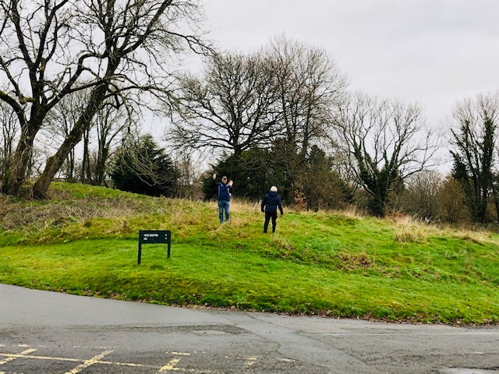  
  
View from timeshare village entrance  
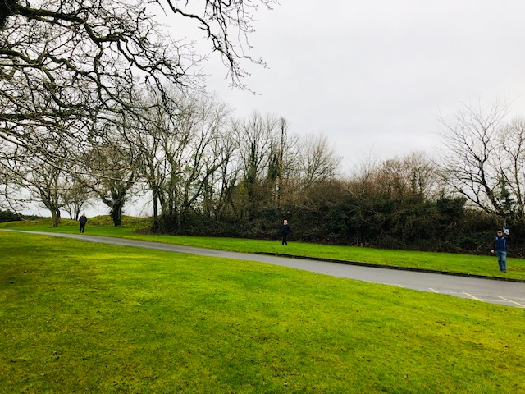  
  
Outside time share village entrance. The people show where three holiday homes will be built

holiday homes will be built  
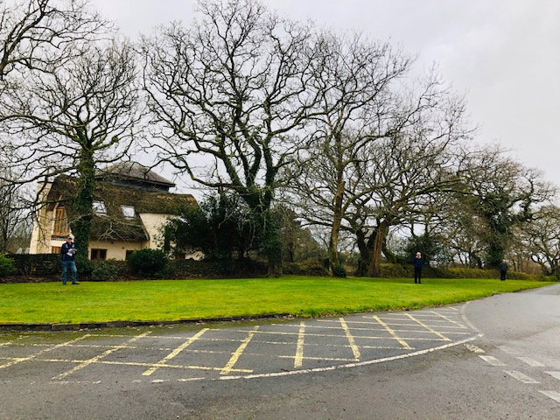

View of property at entrance to timeshare village which will be demolished for three holiday homes

View of property which will be demolished for three holiday homes  
  
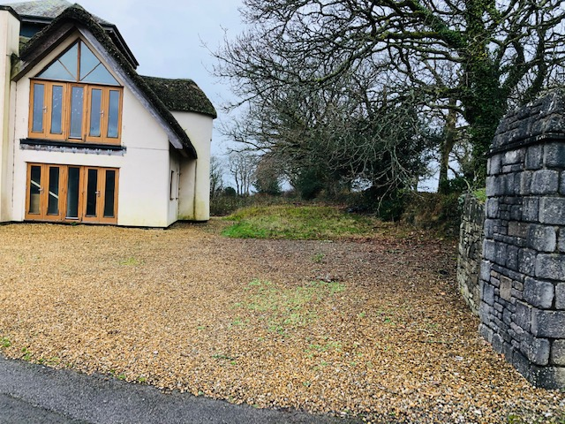

Inside timeshare village entrance, where property in view will be demolished and replaced by three holiday homes

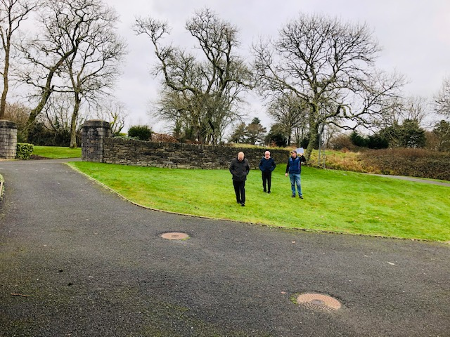

Turn around and even this spare bit of land is having a holiday home on it