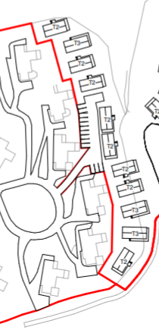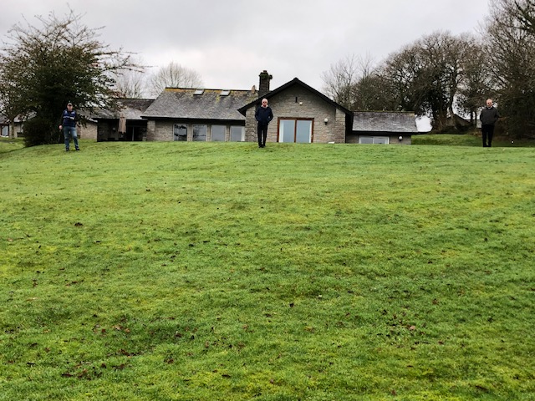

Lodge 6

Lodge 5

Lodge 4

Lodge 3

Lodge 2

Lodge 1



Lodge 1 – The three people represent where each holiday home will start and go down the slope

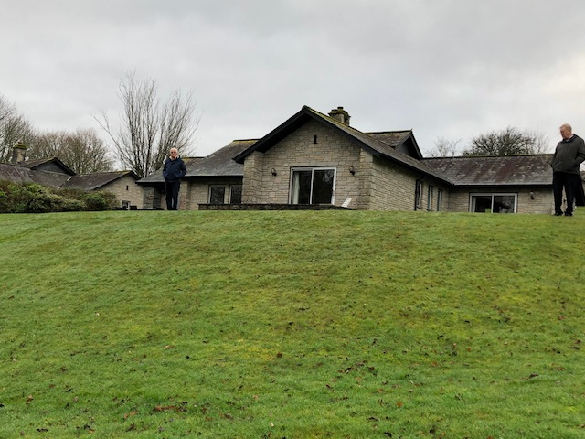

Lodge 2 – The right hand person represents where a holiday home will start, the left hand person represents where the car parking ends

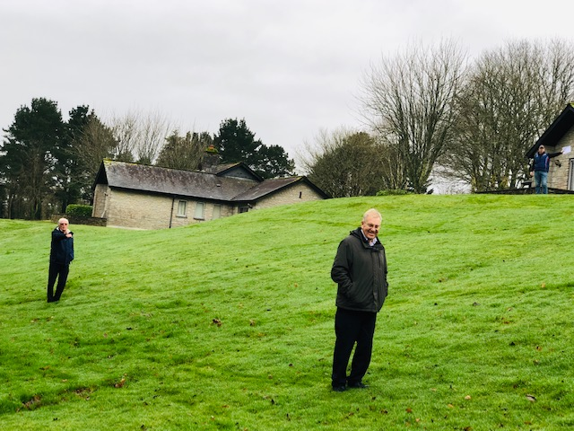

Lodge 3 – The people at the forefront represents where two holiday homes will start The person at the top in front of Lodge 3 represents where the car parking starts

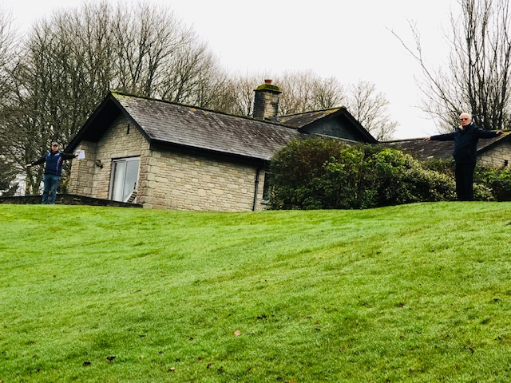

Lodge 3 & 4 – The person in a T shape for traffic represents where the road will be between Lodges 3 & 4 to access car parking

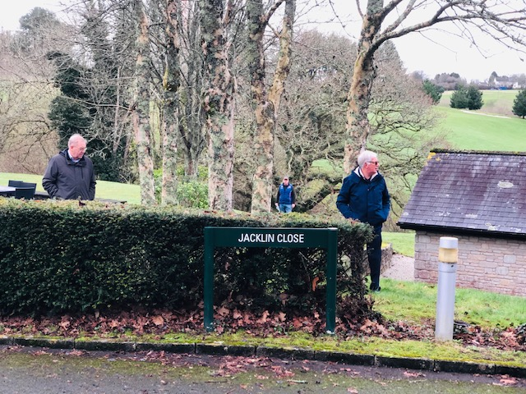 Lodge 3 & 4 – The people in the foreground represent the width of the access road between Lodge 3 & 4. The person in the background represents where the access road to the car parking will go. 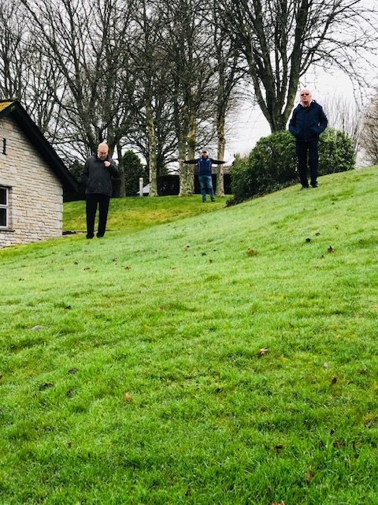

Where the road goes between Lodges 3 & 4. Look at closeness to bedrooms and slope

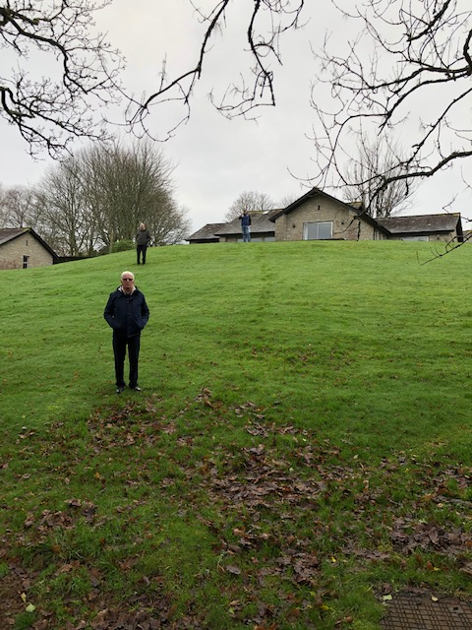

The three people demonstrate the slope of the bank behind the lodges

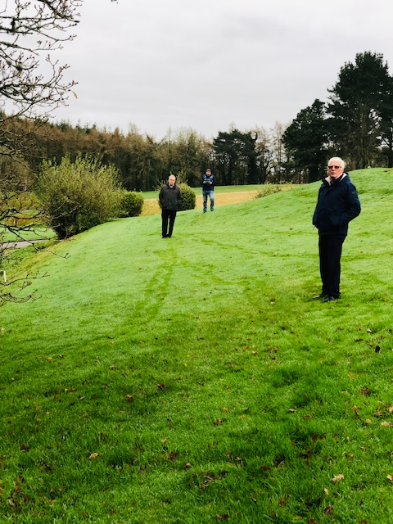

Lodge 4 – The people represent where three holiday homes will go behind Lodge 4

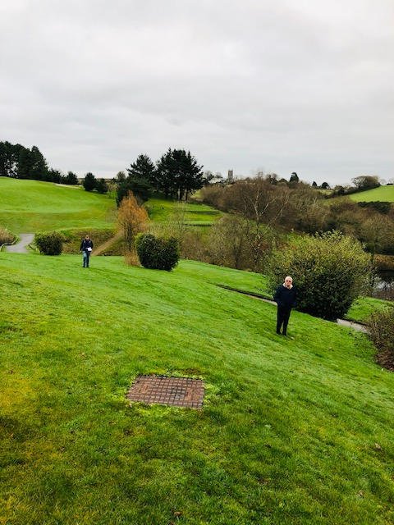

Lodge 5 & 6 – The people represent where two holiday homes will go behind Lodge 5 & 6 and very close to 17th tee box of the Kernow golf course

Further evidence of proximity to golf course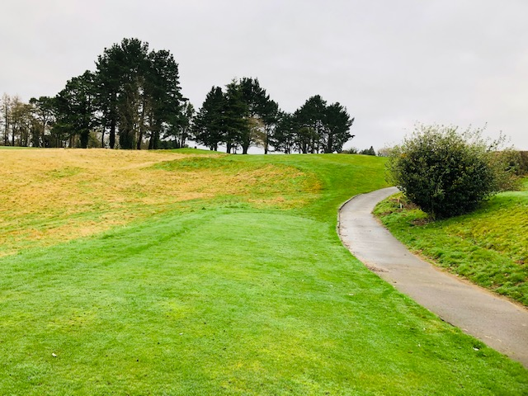

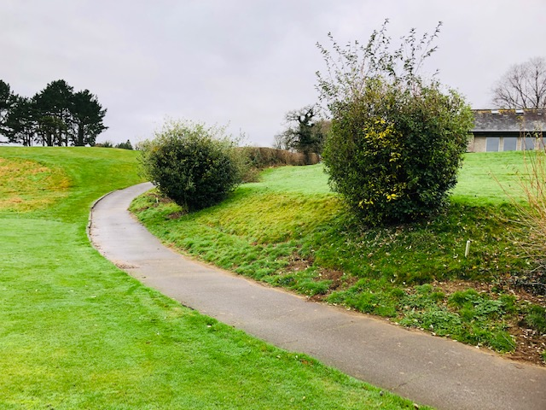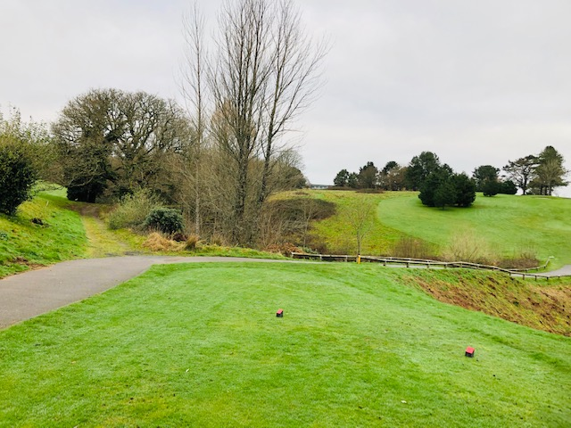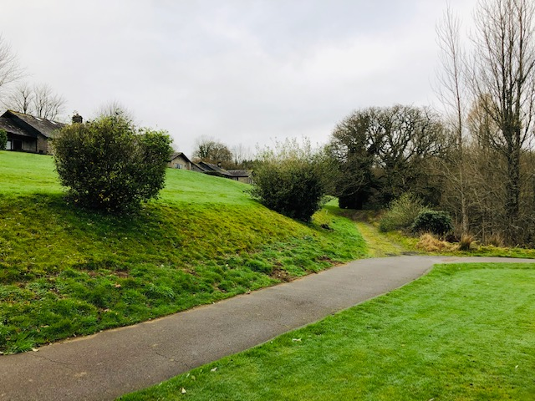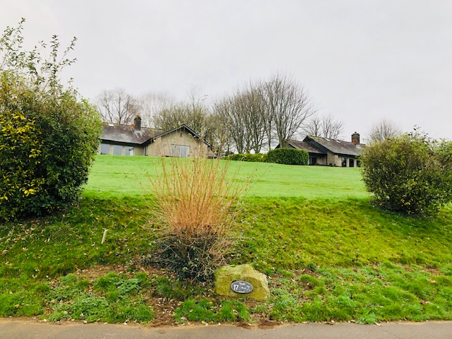

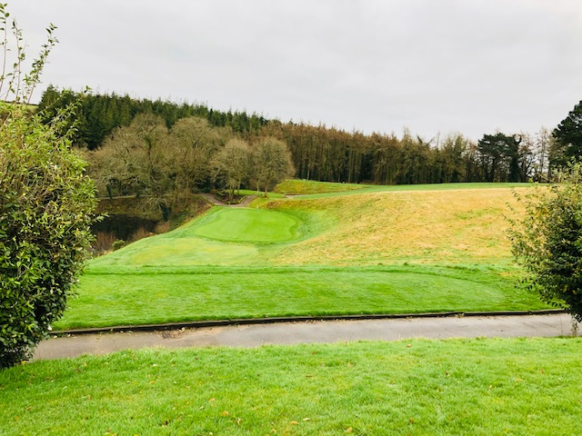

Different views to show slope behind lodges 1 - 6