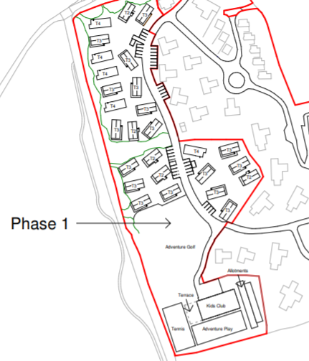

Lodge 10

Lodge 9

Lodge 8

Lodge 7

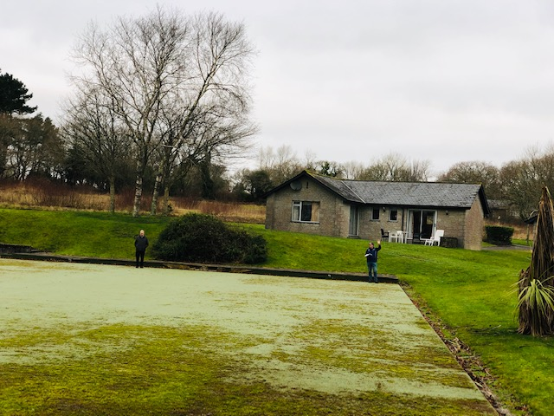

Two people in front of Lodge 10 to demonstrate where the Kids Club will be sited

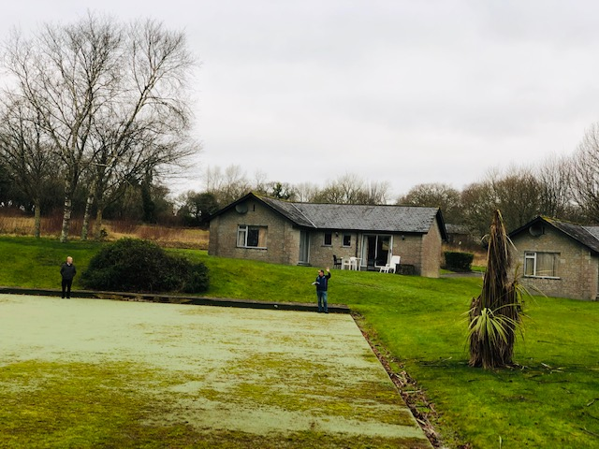

Again two people demonstrating where Kids Club building will sited right behind Lodges 9 & 10

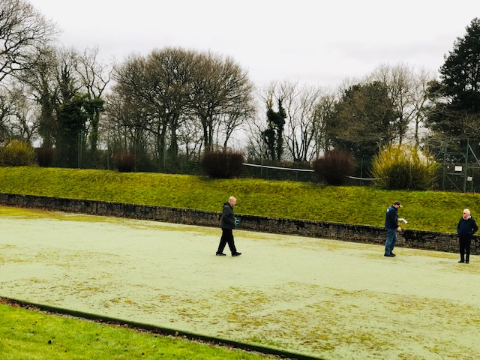

Another view with the tennis courts in the background

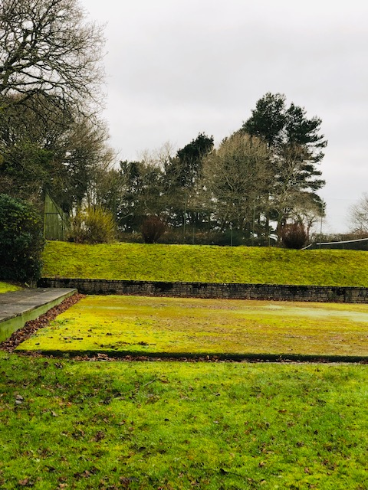  
Other end where Adventure Play will be sited with terrace and tennis courts in background

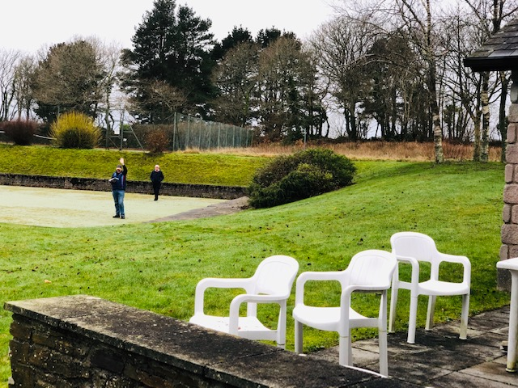  
  
Two people demonstrate how close Kids Club building will be to Lodge 9

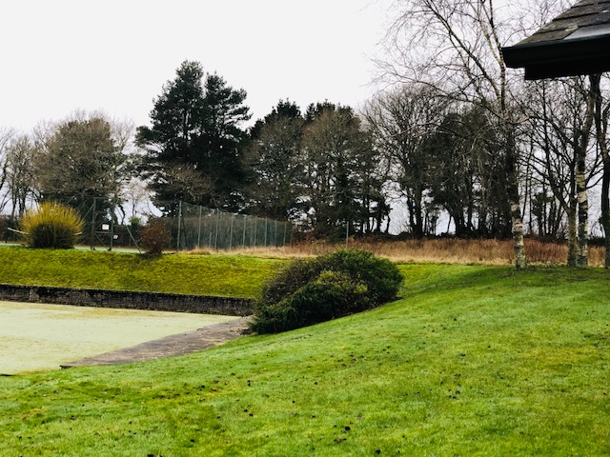

Slope behind Lodge 10 with terrace in background and existing tennis courts

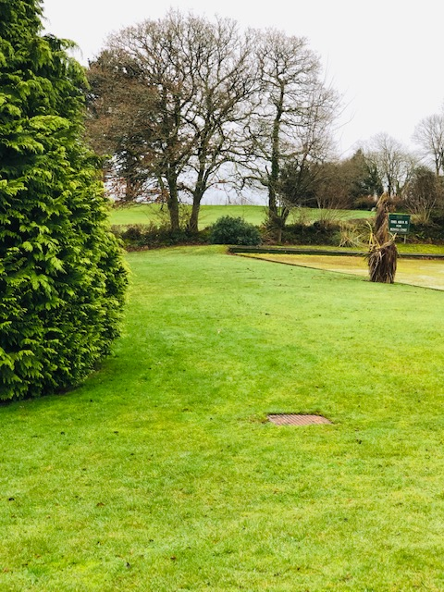  
Where allotments will be behind Lodges 8 & 9. Note the 16th hole of the Kernow golf course in the background and how the noise from the Adventure Play area and Kids Club will impact the golfers  
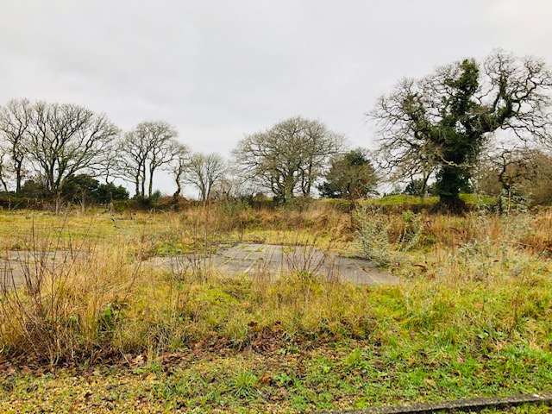  
  
Where we think the Kids Play Area, Adventure area, Adventure Golf and allotments should be located at the entrance to the site which will reduce traffic throughout the existing Timeshare Village and noise to the golf course.  
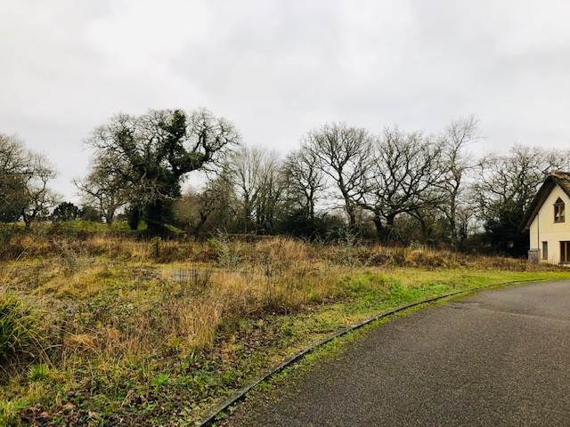  
  
Another view of the area showing the building at the entrance which will be demolished  
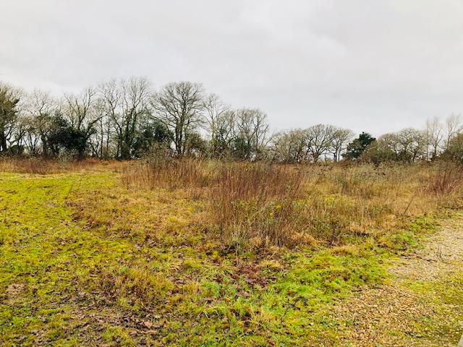  
  
View of site from middle towards the entrance  
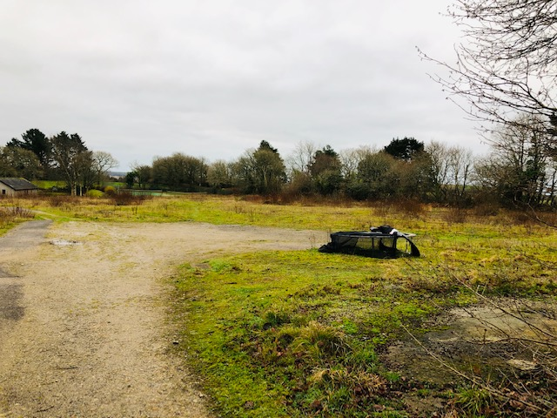  
  
Another view looking down the site towards the tennis course and proposed Adventure Golf  
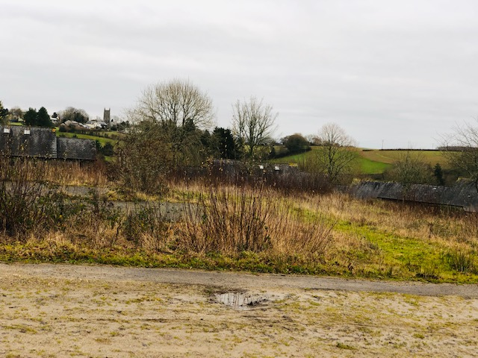  
  
Proposed site of 7 holiday homes as part of the 28 holiday homes proposed on the site. This is against the original lease where 12 additional timeshare lodges was proposed to complete the timeshare village. An additional 16 holiday homes to the original lease which demonstrates the over development of the site and will make it look like a holiday park  
  
  
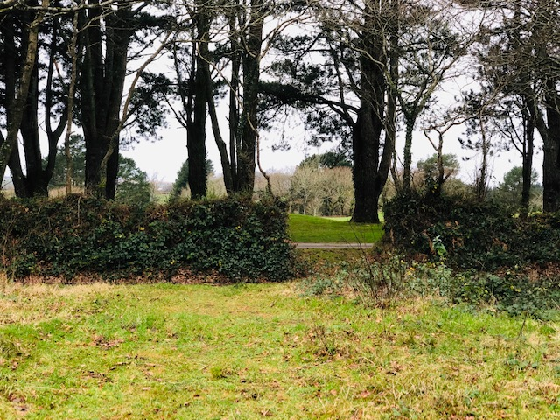  
  
Middle of site to demonstrate closeness to golf course in the background through the gate  
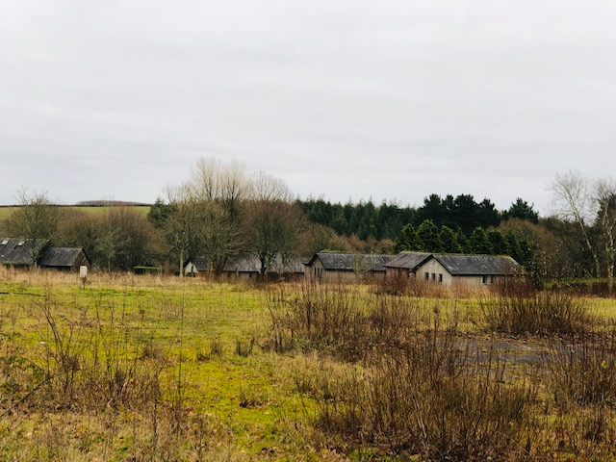  
  
Lodges 9 & 10 in the background and where 7 holiday homes will go  
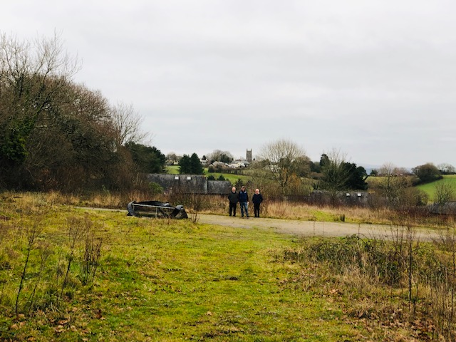  
  
Three people demonstrate where access road will go and you can see St Mellion village church in the background

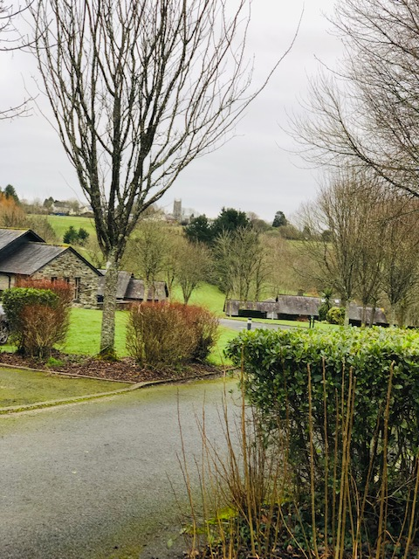  
  
Entrance to site from the existing timeshare lodges  
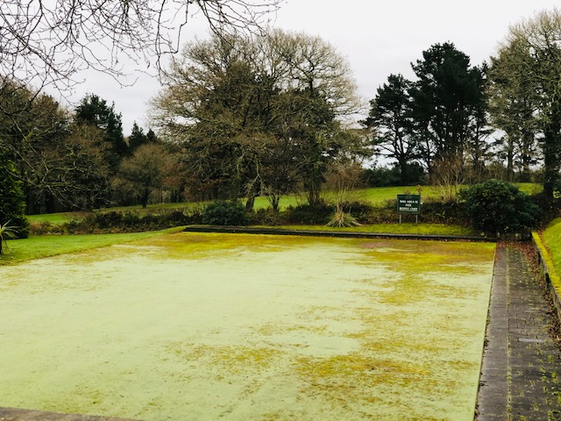  
  
View of where all the kids activity will take place with 16th golf hole of the Kernow course in the background  
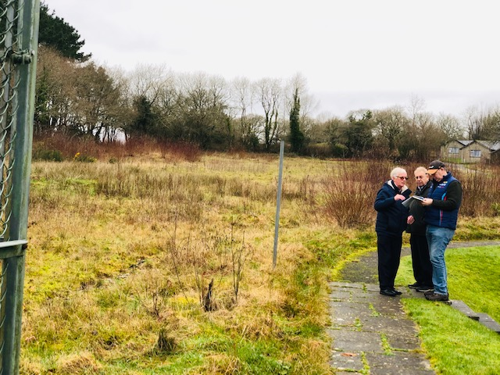  
  
View looking up the whole site from the tennis courts  
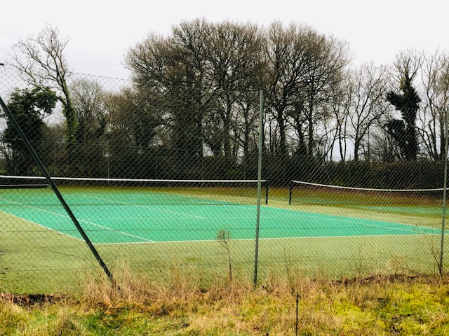  
  
Existing tennis courts  
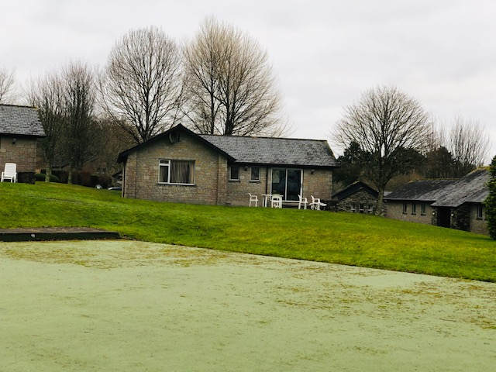  
  
Kids club behind Lodge 9  
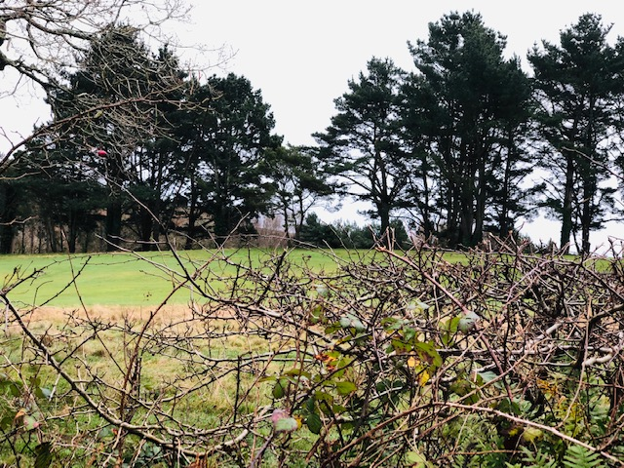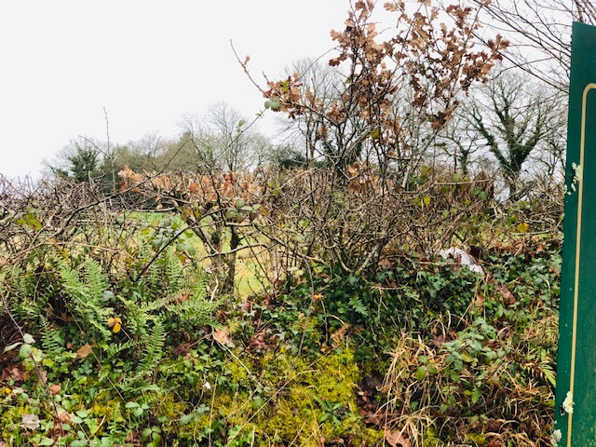  
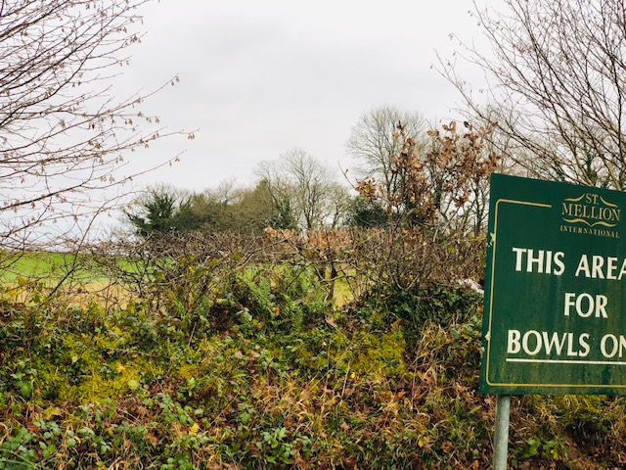  
  
How close 16th is to kids area. Just a hedge in between