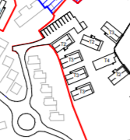

Lodge 37

Lodge 35

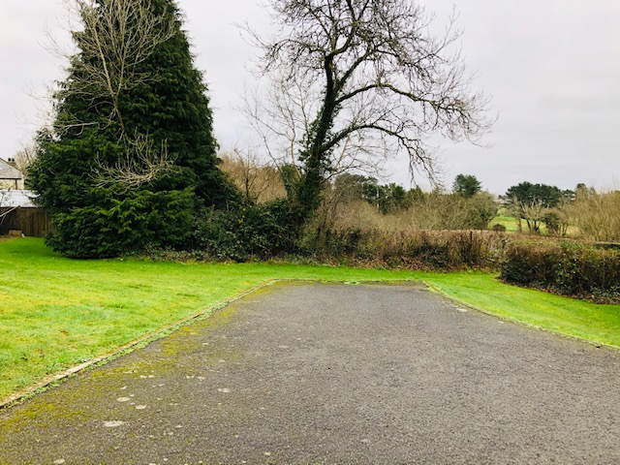

By the side of Lodge 35 where the car parking is going

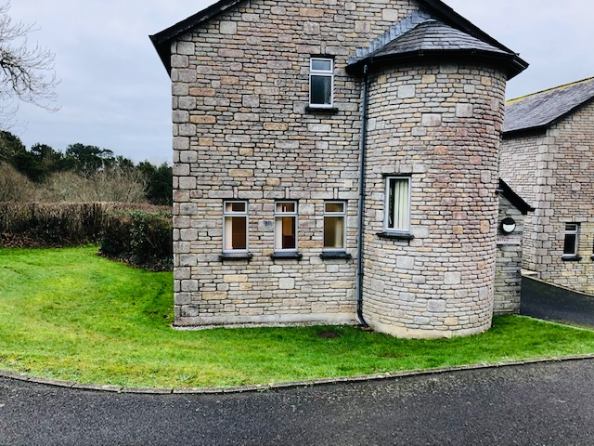

Front view of Lodge 35

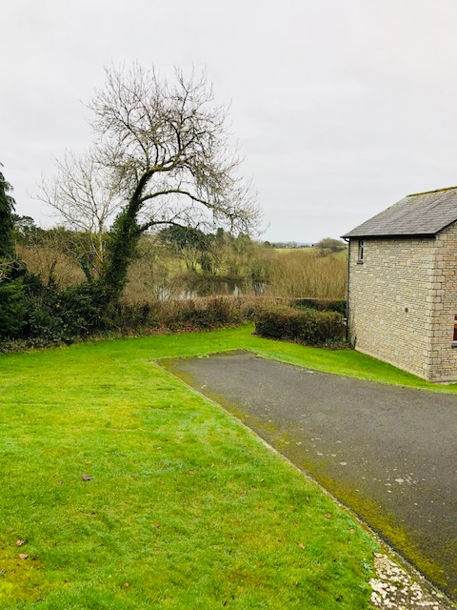

View to show how close the car parking is to Lodge 35

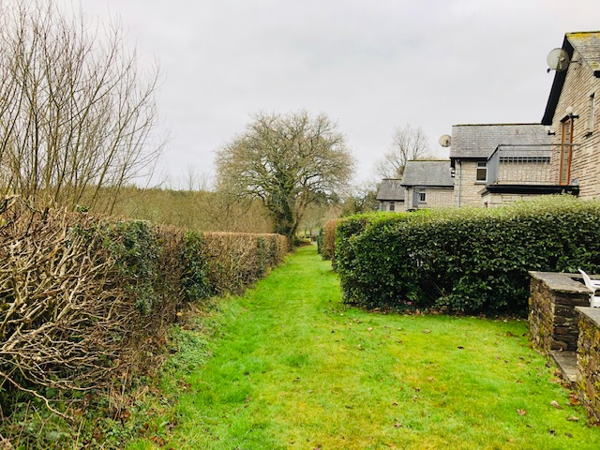

Behind Lodges 35 & 37 where 4 holiday homes are going to go

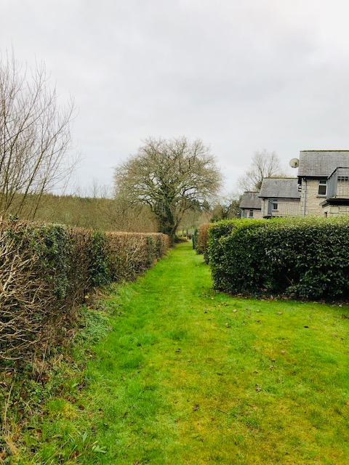

Second view of where 4 holiday homes are going to along the hedge